Experiment 3 : write the python program for water jug problem
Aim
To solve the Water Jug Problem using Python and obtain the target quantity of water using two jugs of different capacities.
Algorithm
- Fill the first jug completely.
- Pour water from the first jug into the second jug until the second jug becomes full.
- Empty the second jug when it is full.
- Continue transferring water between the jugs.
- Repeat the process until the target quantity is obtained.
Program
# Water Jug Problem
jug1 = 4
jug2 = 3
target = 2
print("Jug1\tJug2")
a = 0
b = 0
while a != target and b != target:
if a == 0:
a = jug1
print(a, "\t", b)
elif b == jug2:
b = 0
print(a, "\t", b)
else:
transfer = min(a, jug2 - b)
a -= transfer
b += transfer
print(a, "\t", b)
print("\nTarget reached!")
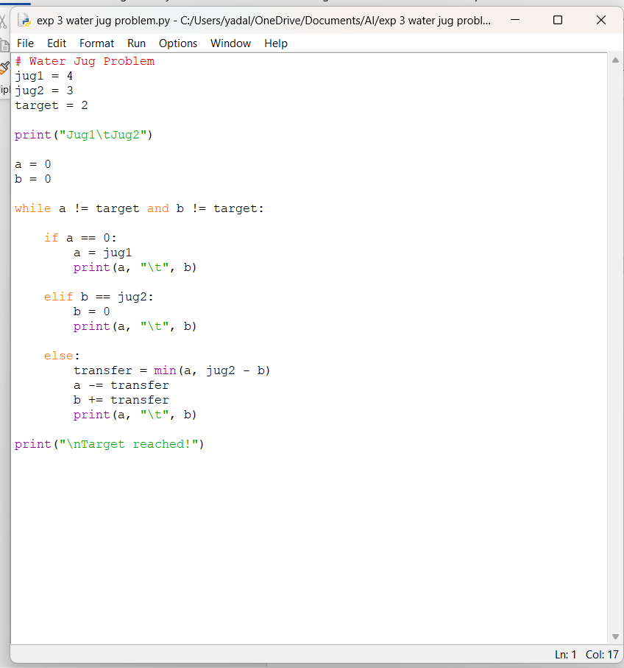
Sample Output
Jug1 Jug2
4 0
1 3
1 0
0 1
4 1
2 3
Target reached!
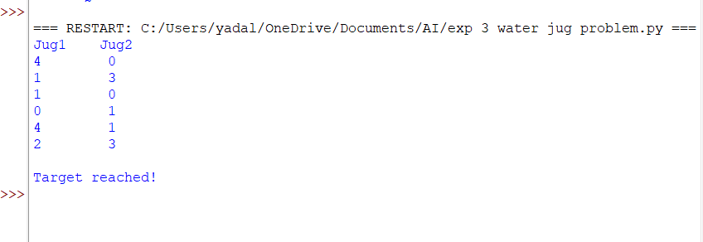
Result
The Water Jug Problem was successfully solved using Python. The target quantity of 2 liters was obtained using a 4-liter jug and a 3-liter jug.

